**Launch X431 V 8inch Tablet Wifi/Bluetooth Full System Diagnostic Tool**  
  
**What is X431 V 8 inch Tablet Diagnostic Tool?**  
  
Launch X431 V is a drop-tested Android™ based scan tool tablet with an 8″ high resolution IPS touch screen (1280 x 800).It inherits from LAUNCH's advanced diagnosing technology and is characterized by covering a wide range of vehicles, featuring powerful functions, and providing precise test result.Through the Bluetooth communication between vehicle diagnostic connector and variant mobile intelligent terminals, it achieves X-431 series full car model and full system vehicle trouble diagnosis, which includes Reading DTCs, Clearing DTCs, Reading Data Stream, Actuation Test and Special Functions.  
  
**Top 8 Reasons to Buy Launch X431 V 8inch:**  
  
**1. Multi-Languages:** English, German, Japanese, Russian, French, Korea, Arabic, Spanish, Italian, Portuguese, Polish, Turkish, Dutch, Greek, Hungarian, Arabic, Danish, Persian, Romanian, Serbian, Finnish, Swedish and Czech  
**2. One-Click Free Update Online for 2 Years,**update cost is 399.00USD/Year, after first two years  
3**. Dealer Code: 755D, no IP or language limitation,** directly to use  
4. Communicate with vehicle via Wifi and Bluetooth, Bluetooth distance:10M (without obstacle)  
5. Full system diagnosis and fast running speed, Reasonable PDA design, easy to carry  
**6. Work on to 69 car brands about 220 car models from European, USA, Asian, Australian, Indian, Malaysian cars,** such asBenz, BMW, Ford and other mainstream models, also support IRKIA, PERODUA, Proton, TATA, Maruti, Lancia etc.  
**7. Support 11 Special Functions Full System Diagnosis:** Brake reset, Oil reset, SAS Rest, BAT reset, Bleeding , Elec. throttle Relearn, TPMS reset, DPF reset., Gear learning, IMMO, etc, also support special function such as BMW idle study, BMW injection rate adjustment, BMW battery replacement, Nissan matching key.  
**8. US Warehouse Ship for customers from USA, UK Warehouse Ship for European Union customers, Tax Free with Fast Delivery**  
  
**Launch X431 V 8inch Functions:**  
   
**Diagnosis:**  
  
Diagnose the electronic control system of prevailing vehicle models covering Asian, European, American and Chinese. Diagnosis functions include: Read DTCs, Clear DTCs, Read data stream, Special functions etc.  
  
**Specific Functions:** Brake reset, Oil reset, SAS reset, ABS reset, DPF reset, ETS reset,BMS reset, Injec Reset, TPMS reset, Gear Reset, IMMO Reset, etc.  
Take "1# injector" as an example. To detect whether 1# injector works normally or not, tap "1# injector", the system will automatically carry out the function. After complete, a prompt dialog box will pop up on the screen.

**Reset Service Functions:**  
  
In addition to amazing & powerful diagnostic function, X-431 V also features various service functions. The most commonly performed service functions contain:  
  
**1) Oil Reset Service**  
This function can be performed in the following cases:  
a). If the service lamp is on, you must provide service for the car. After service,you need to reset the driving mileage or driving time so that the service lamp turns off and the system enables the new service cycle.  
b). After changing engine oil or electric appliances that monitor oil life, you needto reset the service lamp.'  
   
**2) Steering Angle Calibration**  
a). To reset the steering angle, first find the relative zero point position for the car to drive in straight line. Taking this position as reference, the ECU can calculate the accurate angle for left and right steering.  
b). After replacing the steering angle position sensor, replacing steering mechanical parts (such as steering gearbox, steering column, end tie rod, steering knuckle), performing four-wheel alignment, or recovering car body,you must reset the steering angle.  
   
**3) Electronic Parking Brake Reset**  
a). If the brake pad wears the brake pad sense line, the brake pad sense linesends a signal sense line to the on-board computer to replace the brake pad.After replacing the brake pad, you must reset the brake pad. Otherwise, the car alarms.  
b). Reset must be performed in the following cases:  
The brake pad and brake pad wear sensor are replaced.  
The brake pad indicator lamp is on.  
The brake pad sensor circuit is short, which is recovered.  
The servo motor is replaced.  
   
**4) ABS Bleeding**  
This function allows you to perform various bi-directional tests to check the operating conditions of Anti-lock Braking System (ABS).  
a). When the ABS contains air, the ABS bleeding function must be performed to bleed the brake system to restore ABS brake sensitivity.  
b). If the ABS computer, ABS pump, brake master cylinder, brake cylinder, brake line, or brake fluid is replaced, the ABS bleeding function must be performed to bleed the ABS.  
   
**5) Electronic Throttle Position Reset / Learn**  
This function enables you to initialize the throttle actuators so that the “learned” values stored on ECU are returned to the default state. Doing so can accurately regulate throttle (or idle engine) operations to control the amount of air intake. Throttle matching must be performed in the  following cases:  
a) The ECU is replaced and the ECU does not yet store throttle working features.  
b) The ECU is disconnected from power and the ECU memory is lost.  
c) The throttle assembly is replaced.  
d) The intake pipe is replaced or removed, which affects idle speed control by ECU and throttle body.  
e) The throttle is cleaned. Although the idle throttle potentiometer features remain unchanged, with the same throttle opening, the air inflow has changed and idle speed control features have changed.  
   
**6)  Battery Register/Battery Maintenance**  
This function enables you to perform a resetting operation on the monitoring unit of vehicle battery, in which the original low battery fault information will be  cleared and battery matching will be done.  
Battery matching must be performed in the following cases:  
a) Main battery is replaced. Battery matching must be performed to clear original low battery information and prevent the related control module from detecting false information. If the related control module detects false information, it will invalidate some electric auxiliary functions, such as automatic start & stop function, sunroof without one-key trigger function,power window without automatic function.  
b) Battery monitoring sensor. Battery matching is performed to re-match the control module and motoring sensor to detect battery power usage more accurately, which can avoid an error message displaying on the instrument panel.  
   
**7)  Diesel Particulate Filter (DPF) Regeneration**  
DPF regeneration is used to clear PM (Particulate Matter) from the DPF filter through continuous combustion oxidation mode (such as high temperature heating combustion, fuel additive or catalyst reduce PM ignition combustion) to stabilize the filter performance.  
DPF regeneration may be performed in the following cases:  
a) The exhaust back pressure sensor is replaced.  
b) The PM trap is removed or replaced.  
c) The fuel additive nozzle is removed or replaced.  
d) The catalytic oxidizer is removed or replaced.  
e) The DPF regeneration MIL is on and maintenance is performed.  
f) The DPF regeneration control module is rep  
g) Tire Pressure Monitor System Reset  
  
**Launch X431 V 8inch Support Vehicle List:**  
Supports most car models from European, USA, Asian, Australian, Indian and Malaysia.  
**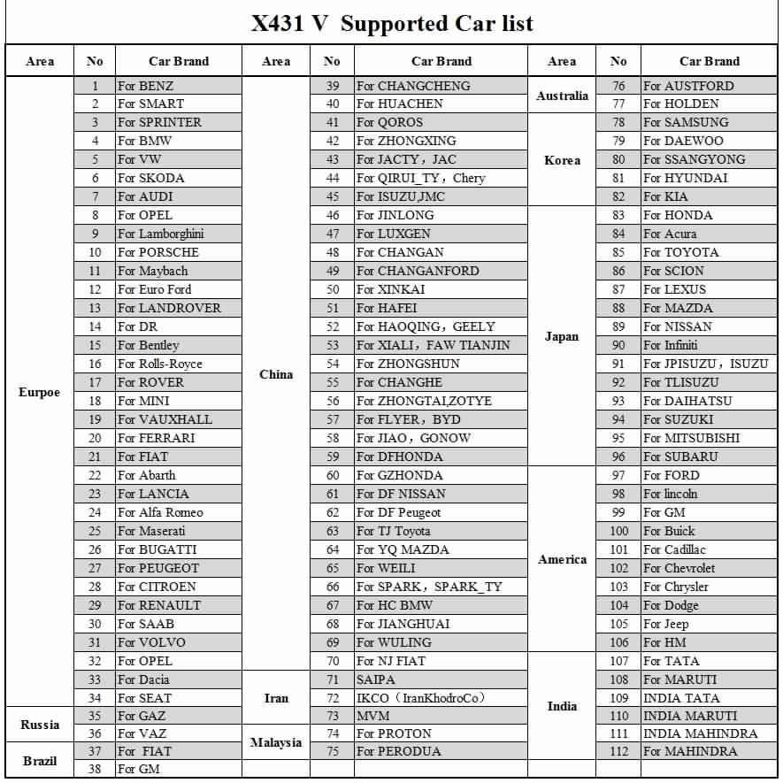  
  
How to connect with Launch X431 V?**  
   
X431 V communicates via Bluetooth, it is very easy to use.  X431 V Pad computer is specially designed for Android platform with clear and user-friendly interface. X431 V Pad computer is equipped with an exclusive X-431 V protection sleeve to prevent it from being damaged;  
   
The owner can use golo connector to connect to his smart phone, then he can do a all system fault diagnosis of vehicle at any time, then form a diagnosis report, and transfer the report to maintenance technicians and related personnel through the account management interface, then he get the remote consultation and repair advice.

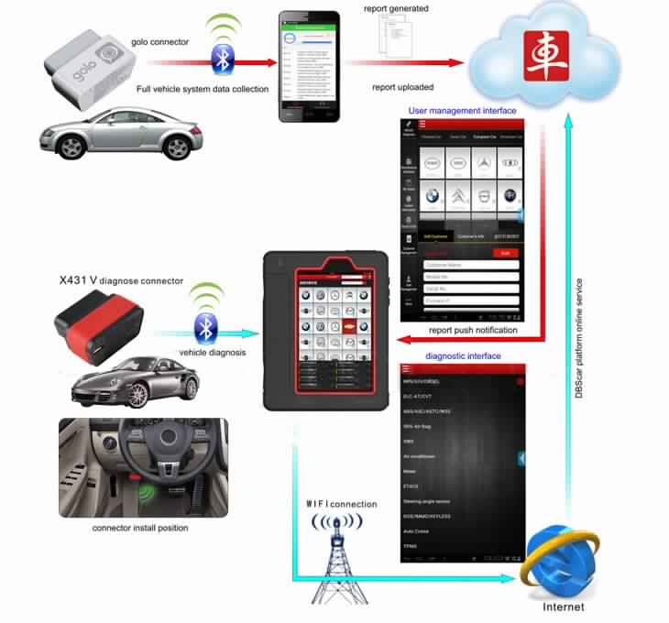 **Launch x431 V 8 inch Tablet Applications:**

|  |  |
| --- | --- |
| Operating system | Android 4.2 |
| CPU: | Quad core 1GHz |
| Display | 8” 1280 x 800 IPS display with 189 ppi |
| RAM | 1 GB |
| Capacity (internal / SD card) | 16GB (expandable by up to 32 GB) |
| Battery | 4200mh rechargeable polymer lithium battery |
| Camera | Front-facing 2 MP camera and rear-facing 5 MP camera with 1080p HD video recording |
| Communication | Wi-Fi: WLAN 802.11b/g/n Bluetooth: Bluetooth 4.0 |

Working temperature 0℃ ~ 45℃  
Storage temperature -10℃ ~ 50℃  
Working voltage: 9 ~18V  
Average working current: About 35mA  
Standby current: About 25mA  
Storage humidity: <80%  
Working humidity: <60%

**Launch X431 V Packing List:**  
  
While opening X-431 V package for the first time, please carefully check the following components:  
1pc x X-431 v handset  
1pc x Password envelope  
1pc x X-431 v protection sleeve  
1pc x DBScar diagnostic connector (For connecting OBD II vehicles)  
1pc x OBD II extension cable  
1pc x Cigarette lighter cable  
1pc x Power adaptor  
1pc x USB data cable  
1pc x Non-16pin connector  (For connecting non-OBD II vehicle)